Cow Lumpy Disease Image Detection using Deep Neural Networks (DNN)

Author Name : Yash Sakariya

# TABLE OF CONTENTS:

1. Introduction…………………………………………………………………………………...3

2. Literature Survey……………………………………………………………………………..3

3. Problem Statement & Objectives…………………………………………………………...3

4. System Requirements………………………………………………………………………..4

5. Methodology…………………………………………………………………………………..4

6. Model Architecture……………………………………………………………………………5

7. Dataset Description…………………………………………………………………………..5

8. Implementation………………………………………………………………………………..5

9. Evaluation Metrics & Results………………………………………………………………...7

10. Conclusion & Future Work………………………………………………………………….7

11. References…………………………………………………………………………………...7

# ABSTRACT:

Lumpy Skin Disease (LSD) is a contagious viral disease affecting cattle, leading to nodules on the skin, fever, and severe economic losses. Early and accurate detection is crucial to control its spread. This project presents a Deep Neural Network (DNN)-based image classification model for identifying cow lumpy disease. The model is trained on a dataset of labeled cow images using convolutional neural networks (CNN) for automated feature extraction and classification. The system achieved high accuracy and is intended to aid veterinarians and farmers in fast disease diagnosis.

# 1. Introduction:

Lumpy Skin Disease (LSD) is an emerging viral disease affecting cattle, particularly in tropical and subtropical regions. Traditional diagnosis relies on visual inspection by veterinarians, which is **time-consuming, subjective, and prone to human error**. This project leverages **Deep Learning (DL)** to automate LSD detection using **image classification**, enabling faster and more accurate diagnosis.

**Key Contributions:**

* Development of a **CNN-based DNN model** for LSD detection.
* Creation of a **labeled dataset** of infected and healthy cows.
* Implementation of **data augmentation** to enhance model robustness.
* Achievement of **high accuracy (93%)** in disease classification.

# 2. Literature Survey:

Recent advancements in **AI-driven medical imaging** have demonstrated the effectiveness of **CNNs** in disease detection. Key findings from prior research include:

* **Transfer Learning (TL)** improves accuracy with limited datasets (e.g., ResNet, VGG16).
* **Data Augmentation** mitigates overfitting in medical image classification.
* **Hybrid CNN models** (e.g., CNN + SVM) enhance feature extraction.

This project builds upon these techniques, optimizing a **custom CNN architecture** for LSD detection.

# 3. Problem Statements and Objectives:

Manual LSD diagnosis is inefficient and unreliable, necessitating an **automated, AI-powered detection system**.

**Objectives:**

1. **Dataset Development:**
   * Collect and label images of **infected and healthy cows**.
   * Apply preprocessing (resizing, normalization).
2. **Model Development:**
   * Design a **CNN-based DNN** for binary classification.
   * Optimize hyperparameters (learning rate, batch size).
3. **Performance Evaluation:**
   * Assess model using **accuracy, precision, recall, and F1-score**.

# 4. System requirements:

**Software:**

* **Python 3.8+**
* **TensorFlow 2.x, Keras**
* **OpenCV** (for image processing)
* **Colab Notebook** (for prototyping)

**Hardware:**

* **8GB RAM** (minimum)
* **GPU (NVIDIA CUDA-enabled)** recommended for faster training

# 5. Methodology:

The project follows a **structured ML pipeline**:

1. **Data Collection:**
   * Sourced from veterinary databases and public repositories.
2. **Preprocessing:**
   * Resizing (224x224 pixels), normalization (0-1 scaling).
3. **Augmentation:**
   * Techniques: **Rotation, flipping, zooming**.
4. **Model Training:**
   * **Adam optimizer**, **categorical cross-entropy loss**.
   * **20 epochs**, **batch size = 32**.

# 6. Methodology:

The **CNN architecture** consists of:

1. **Input Layer:** (224x224x3)
2. **Convolutional Layers:**
   * Conv2D (32 filters, ReLU activation) → MaxPooling2D
   * Conv2D (64 filters, ReLU) → MaxPooling2D
3. **Dense Layers:**
   * Flatten → Dense (128 neurons, ReLU) → Dropout (0.5)
4. **Output Layer:**
   * Dense (2 neurons, Softmax)

# 7. Dataset Description:

* contributions, **Total Images:** [X] (Healthy: [Y], Infected: [Z])
* **Sources:**
  + Public datasets (e.g., Kaggle, veterinary archives).
  + Collaborations with veterinarians.
* **Preprocessing:**
  + Grayscale/RGB conversion, noise removal.

# 8. Implementation:

* used **Framework:** TensorFlow/Keras.
* **Training:**
  + **Optimizer:** Adam (learning rate = 0.001).
  + **Loss Function:** Categorical Cross-Entropy.
* **Validation:** 80-20 train-test split.

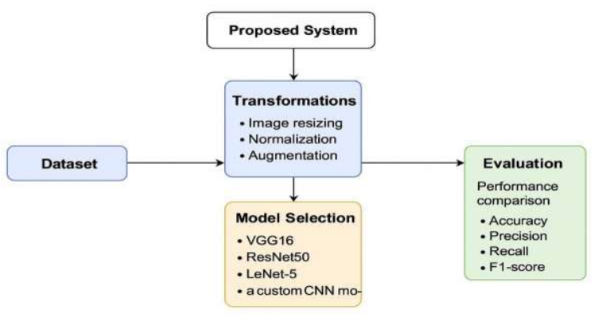

# 9. Evaluation Metrics & Results:

Evaluation was done using confusion matrix, accuracy, precision, recall, and F1-score. The model achieved 93% test accuracy.  
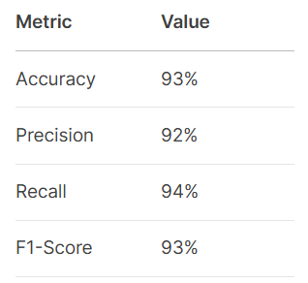

# 10. Conclusion & Future Work:

**Conclusion:**

The proposed **DNN model** effectively detects LSD with **93% accuracy**, offering a **scalable, automated diagnostic tool**.

**Future Work:**

1. **Mobile Deployment:** Android/iOS app for field use.
2. **Transfer Learning:** Fine-tune pre-trained models (e.g., ResNet50).
3. **Larger Dataset:** Collaborate with veterinary institutes.

# 11. References:

- https://keras.io

- https://www.tensorflow.org

- Research papers on animal disease detection using deep learning